# CLASS: T. E. (E &TC) SUBJECT : DC

**EXPT. NO.: 10 DATE :**

# Roll no:32457

**TITLE : NOISE GENERATION & MATCHED FILTER PREREQUISITES**

**FOR EXPT.** : Analytical analysis of matched filter, Line coding techniques,

Gaussian noise and its generation techniques

**OBJECTIVE :** To study addition and removal of noise (Gaussian) to and from NRZ data.

# APPARATUS :

| Sr.  No. | Apparatus | Range |
| --- | --- | --- |
| 1. | Matched filter kit |  |
| 2. | DSO | Dual Channel, 60 MHz |

**THEORY : Baseband Signalling**

**M-ary Baseband Signals :** An M-ary baseband signal is made up of M symbols each differing in either shape and/or size as shown in fig. 8.1.

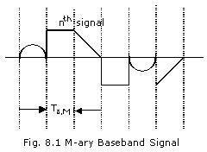

For practical reasons of implementation of signals processing circuits the symbols all have the same duration Ts, m. The probability of occurrence of mth symbol is assumed to be Pm (m=1,2,3…M). In this case, the mth symbol

carries -log2Pm bits of information (the information associated with a source output is the negative logarithm of the probability of the event) [Shannon, 1948].

From a logic implementation point of view M=2 (binary), 4 (quaternary),

8 (octernary), 16 (duo-octernary), etc. are used. Furthermore, the symbol shapes of M-ary baseband signals are made identical and also the separation between adjacent levels is made equal.

The information rate (bit-rate) of an M-ary baseband signal may be derived as fB,M = Average no. of bits in symbol duration / Symbol duration

= *[m=1 m ∑ Pm log (1/Pm)* ] / Ts,M bits/sec (8.1)

where Pm is the probability of occurrence of the mth symbol and Ts, M is the symbol duration of M-ary baseband signal.

If the symbols are equally probable, then

Pm=1/M (8.2)

Substituting eqn.(8.2) into eqn.(8.1), gives fb,M=log2 M (1/TsM) bits/sec (8.3)

It is common that the binary signal (M=2) is taken as the basis for comparison. Since the bit rate for binary signals is

Fb,2 =

1



*Tb*,2

One may write, fb,M = fb,2 (

*Ts*,2



*Ts*,*M*

) log2 M (8.4)

If we assume that Ts,M = Ts,2, then

Fb.M = fb,2 log2M (8.5)

For example, in the case of quaternary signals (M=4), fb,4=2fb,2, that is the bit rate ( information rate) of a quaternary signal is twice that of a binary signal having the same symbol duration ( the same bandwidth).

If we make fb, M=fb,2 then Ts,M = Ts,2log2M. For the same bit rates, in case of quaternary signals, we ha Ts,4 = 2Ts,2 that is symbol duration of quaternary signal is twice that of a binary signal having the same bit rate. In other words, it requires half the channel bandwidth if a binary signal with the same bit rate. (Note that the channel bandwidth required for transmission of a signal is proportional to the inverse of its symbol duration).

One important conclusion from the above is that for a given channel bandwidth it is possible to transmit more information by increasing the number of symbols of the baseband signal.

# M- Level Pulse Amplitude Modulated (PAM) signals.

The most widely used wave shape in baseband systems is the rectangular shaped one, because this shape is less sensitive to the transmission noise and interference. These signals are referred to as M-level PAM signals. As an example, binary (level 2) and quaternary (level 4), Unipolar and bipolar PAM signals are shown below.

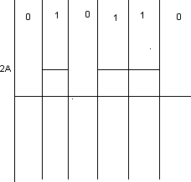 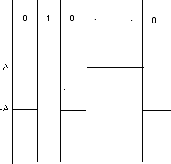

(a). Unipolar 2-level Pam (b) Bipolar 2-level PAm

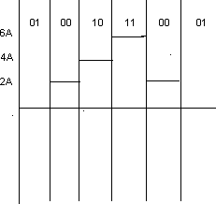 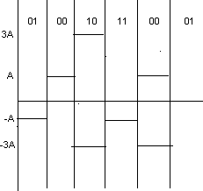

(c). Unipolar 4-level Pam (d). Bipolar 4-level PAM

# UNIPOLAR AND BIPOLAR 2-LEVEL AND 4-LEVEL PAM SIGNALS

Each level of an M-level PAM signal represents log2M bits, e.g. each level of a 4-level (quaternary) signal carries 2 bits. The mapping of the bits on the levels of the signal is frequently performed in accordance with the Gray coding technique, as shown in Figures 8.2c and 8.2d.

# Generation of M-Level PAM signals

The basic signal generated by logic circuits is the unipolar 2-level PAM signal (PCM signal) and all information sources may be encoded into such binary signals by PCM encoder. These signals are also referred to as PCM signals.

The conversion of unipolar PAM signals to bipolar signals may be accomplished by appropriate level shifting. An M-ary level PAM is usually generated from the unipolar 2-level through a (log2M)-stream serial-to-parallel converter followed by a (log2M)-bit D/A converter as shown in Figure 8.3.

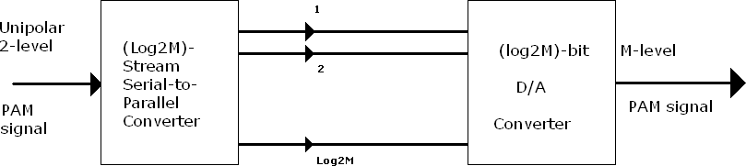

Figure 8.3 : M-level PAM signal construction circuit

A (log2M)-bit A/D converter followed by a (log2M)-stream parallel-to-serial converter regenerates the original binary unipolar PAM signal from the received M level PAM signal as shown in the Figure 8.4

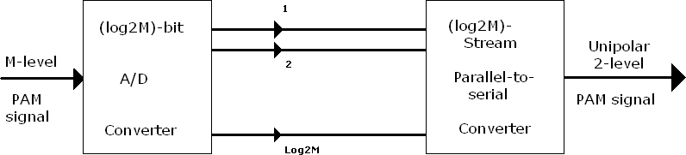

Figure 8.4 : Regeneration circuit of binary PAM signals

M-level bipolar PAM signals are commonly used for baseband signalling of digital communication systems. This is because they have much better performance then that of M-level unipolar signals for a given signal-to-noise ratio (SNR). We will show that later in this chapter. Therefore, hereafter, we only consider M-level bipolar PAM signals and refer to them as M-level PAM signals

# Performance Comparison of Bipolar and unipolar 2- level PAM Signals

For unipolar 2- level signals where ak takes values of 1 or 0 volts and the desired sampled signal has values of 0 or 2A volts depending on whether the transmitted bit at the kth interval is 0 or 1 volts respectively, using a similar approach to that used for the bipolar signal, one can simply obtain the error probability as:

*Pe(unipolar)=1/*2 [1*-erf(A/√2∙σ)*]= *1/*2 *erfc(A/√2∙σ)* (8.37)

From equations (8.33) and (8.37), it is apparent that Pe (bipolar) and

Pe (unipolar) are identical when expressed in terms of separation of the signal levels. However, it is more realistic to compare their performance in terms of the signal to noise ratios (SNR’s). The SNR is defined as:

*S/N = (average signal power) / (average noise power) (8.38)*

For the bipolar signal we have:

*S/N = (powerin’0’. pr[ak=-1] + powerin’1’. pr[ak=1]) /(σ2)*

*[ A2∙(1/2) + A2∙(1/2) ] / σ2 = (A2 / σ2)* (8.39)

and for the unipolar signal:

*S/N = [ 0∙(1/2) + 4A2∙(1/2) ] / σ2 = (2A2 / σ2)* (8.40)

Putting Equation (8.39) and Equation (8.40) into Equation (8.37), we obtain the error probabilities in terms of the SNR.

*Pe(bipolar) = (½) erfc (1/√2) ∙ (√(S/N)b) (8.41)*

*P* 1 ⎧⎪1

⎛  *S* ⎞ ⎫⎪

*e*(*unipolar*) = 2 *erfc*⎨2 ⎜ *N* ⎟*u* ⎬

……………………..(8.42)

⎪⎩ ⎝ ⎠ ⎪⎭

Let us make Pe (unipolar) = Pe (bipolar), then we require

1 ⎛ *S* ⎞

= ⎜ ⎟*u*

2 ⎝ *N* ⎠

or

⎛ *S* ⎞ 1 ⎛ *S* ⎞

*b u*

………………….(8.43)

⎜ *N* ⎟ ⎜ ⎟

⎝ ⎠ 2 ⎝ *N* ⎠

⎛ *S* ⎞*b*(*dB*) = ⎛ *S* ⎞*u*(*dB*) − 3

 

………………..(8.44)

⎜ *N* ⎟ ⎜ *N* ⎟

⎝ ⎠ ⎝ ⎠

The above equation shows the unipolar 2-level signal acquires twice the SNR of a bipolar signal to give the same error probability. In other words the bipolar 2-level signal has a 3 dB noise advantage over the unipolar 2-level signal. In general, bipolar M-level PAM systems are more power efficient than their bipolar counterparts. This is why most baseband signals are bipolar types. We will further consider bipolar baseband signals in the remaining part of these notes and, for convenience; we will drop the word ‘bipolar’.

# Symbol Error Probability of M-level (M>2) Signals Corrupted by AWGN

A block diagram of a basic M-level PAM system is shown in Figure 8.13. It is assumed that the overall system filtering (transmit and receive filtering) has an ideal Nyquist shaping, i.e. causing no ISI and the transmitted signal levels had

only M possible levels ± 1,±3,......,±(*M* − 1)volts with equal probability.

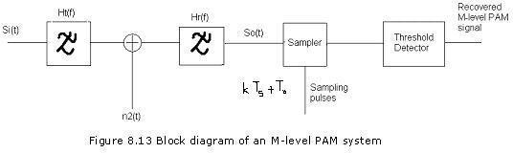

# Optimum Receivers

A receiver is said to be optimum if it minimizes the system error probability. For wideband systems where the signal and noise are not bandlimited (i.e. B>>fb where B is the system bandwidth and fb is the signal bit rate) the error probability will be maximum when the SNR at the sampling instant is maximum. Such optimum receivers, which maximize the SNR at the sampling instant, are commonly referred to as matched-filter receivers. In what follows we find a matched filter-receiver for a binary signal having arbitrary waveforms s1(t) and s2(t) represent logic states ‘0’ and ‘1’ , respectively over the interval 0 to Tb and have finite symbol energies of

*Eb1 = 0∫Tb s12(t) dt* (8.76)

*Eb2 = 0∫Tb s22(t) dt* (8.77)

A block diagram of a wideband matched-filter receiver considered here is shown in Figure 8.20

s(t)=S(t)

s2(t) s1(t

8.20 Simplified block diagram of binary wideband system with a matched filter The wideband signal plus AWGN at the input to the receiver may be writer as

*s2(t) = k=-∞ ∞∑ s(t-kTb) + n(t)* (8.78)

Where s (t) takes the wave shape of s1 (t) or s2 (t) whether a ’0’ or a ’1’ is transmitted, respectively. Without loss of generality for ISI-free transmission, we may consider the signal for k=0, i.e.

s1(t) + n1(t) when a ‘0’ is transmitted

st(t) = 0≤ t ≤ Tb

s2(t) + n2(t) when a ‘1’ is transmitted

……………….(8.79)

The sampled signal plus noise at the sampling instant of Tb is given by: s01(Tb)+nH(Tb)

so(Tb)=

s02(Tb )+n0 (Tb) ……… (8.80)

We assume that s1 (t) and s2 (t) are selected such that: s02 (Tb) > s01 (Tb) (8.81)

The threshold level is set midway between s02 (Tb) and s01 (Tb) and this corresponds to the optimum level for equally probable binary symbols which is given by:

lopt = s02(Tb)+s01(Tb) ………(8.82)

2

A decision is made on the basis of:

s1(t)[logic state ‘0’] is transmitted if s0(Tb) ≤ lopt

s2(t)[logic state‘1’] transmitted if s0(Tb)≥lopt (8.83)

where lopt is the optimum threshold level of the comparator.

Since ni(t) is AWGN it follows that n0(Tb) will be a Gaussian random variable of zero mean and variance



σ 2 =n 2(T )

which equals to:

∞

σ2=(No/2)∫ ιHo(f) ι2 df (8.84)

-∞

where N0/2 is the double-sided power spectral density of ni(t). The average error probability for this receiver may be written as:

Pe=P1Pe1+P2Pe2 (8.85)

Where P1 and P2 are the probabilities of transmitting s1 (t) and s2 (t), respectively, and Pe1 and Pe2 are the probabilities of error assuming that s1(t) and s2(t) are transmitted, respectively.

For equiprobable binary symbols, we have:

P1=P2=1/2 (8.86)

Hence equation (8.85) becomes:

Pe=(1/2)(Pe1+Pe2) (8.87)

For notational convenience the time dependence of all the quantities will henceforth be dropped Pe1 and Pe2 are obtained as follows:

∞

Pe1 = pr{S0 > lopt } = ∫ p(s0/s1) ds0 (8.88)

lopt

Where p(s0/s1) is the pdf of s0 (Tb) on condotion that s1(1) is transmitted. Since s0 gaussian random variable with a mean value s01 and the variance delta2 ,then

(S0-S01/ √ σ 2

p(s0/s1) = 1 e (8.89)

√2πσ2

Using equations (8.82) and (8.89)in equation (8.88) gives,

- (S0 - S01/ √ σ 2

Pe1 = 1 ∫ e ds0 (8.90)

√2πσ2 1/2 (S02 - S01)

By change of variable as:

S02 - S01 = X 🡪 ds0 = √2σ dx

√2σ

we have:

∞

PA = 1 ∫ e –x2 dx = 1 erfc [s 02(Tb)-s 01(Tb)] (8.91)

√π (So2-So1 ) 2 2√2σ

2√2σ

Similarly Pe2 can be obtained as :

Pe2 = 1 erfc [s 02(Tb)-s 01(Tb)] (8.92)

2 2√2σ

Substituting equations (8.91) And (8.92) into equation (8.87) yields :

Pe = 1 erfc [s 02(Tb)-s 01(Tb)] (8.93)

2 2√2σ

Where

∞

erfc(z) = 2 ∫ e-x2 ds (8.94)

√π z

Which is a monotonically decreasing function

# Correlation receivers as Matched-filter Receivers

Realizing a matched fillter whose impulse response has to be matched with the received waveforms is difficult. However, there is a widely used structure for matched filter detection, which can be realized. This structure is referred to as ‘correlation receiver’. In the following, we show that a correlation receiver is a matched-filter receiver shown in the fig 8.22.

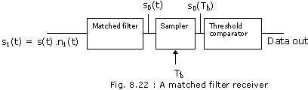

The matched filter output signal may be written as:

*s0(t) =0∫t h0(t-*τ*) s1(*τ*) d*τ (8.125)

The sampled output signal is given by:

*s0(Tb) =0∫Tb h0(Tb-*τ*) s1(*τ*) d*τ (8.126)

Since

*h0(t) =s2(Tb-t) - s1(Tb-t)* (8.127)

then

*s0(Tb) =0∫Tb s1(*τ*)*[ *s2(*τ*) - s1(*τ*)*] *d*τ (8.128)

This result can be implemented by a correlation receiver as illustrated in fig.

8.23. The received signal si(t) is multiplied by a locally generated waveform s2(t) - s1(t).The output of the multiplier is passed through an integrator and then sampled at the end of each symbol. Finally, the threshold comparator gives logic state ‘1’ or ‘2’ depending on whether the sampled value is larger or smaller than specific threshold level. At the beginning of each new symbol all the energy stored in the integrator must be discharged by dump circuit.

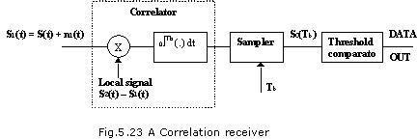

# PROCEDURE:

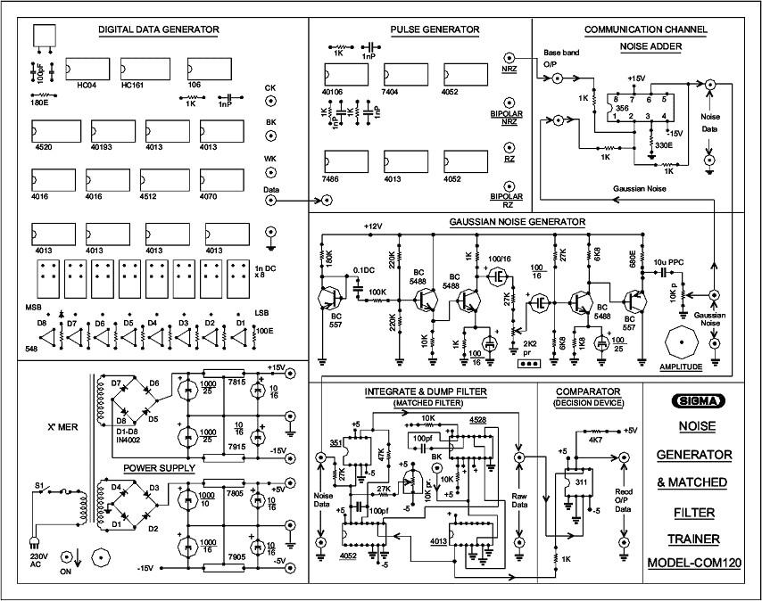

1. Observe Carrier Clock (Ck)
2. Observe Bit Clock (Bk)

Waveform (W1)

Waveform (W2)

1. Observe Word Clock (Wk) Waveform (W3)
2. Observe NRZ DATA (NRZ) Waveform (W4)
3. Observe NRZ, Bipolar NRZ, RZ, Bipolar RZ signals.

Waveform (W5 to W8)

1. Observe Gaussian noise output Waveform (W9) Keep noise level at minimum.
2. Observe noisy baseband NRZ signal at o/p of noise adder section.

Waveform (W10)

1. Observe raw data signal at output of matched filter.

______Waveform (W11)

1. Observe received pure NRZ data at the output of comparator.

Waveform (W12)

1. Now add Gaussian noise by rotating noise level pot and observe its effect on all received signals.

# OBSERVATIONS AND GRAPHS:

1. Observe & plot NRZ data.
2. Observe & plot Gaussian Noise.
3. Observe & plot data with noise (Adder o/p).
4. Observe & plot raw data at o/p of matched filter.
5. Observe & plot recovered NRZ data.

# 

# CONCLUSION:

# In this practical we studied matched filter

# We studied addition and removal of noise (Gaussian) to and from NRZ data.

# The matched filter is the optimal linear filter for maximizing the signal-to-noise ratio (SNR) in the presence of additive stochastic noise. Matched filters are commonly used in radar, in which a known signal is sent out, and the reflected signal is examined for common elements of the out-going signal

**RERFERENCES:**

* 1. Modern Digital & Analog communication system-B.P.Lathi
  2. Sigma Trainer Manual
  3. “Communication Systems”- Carlson